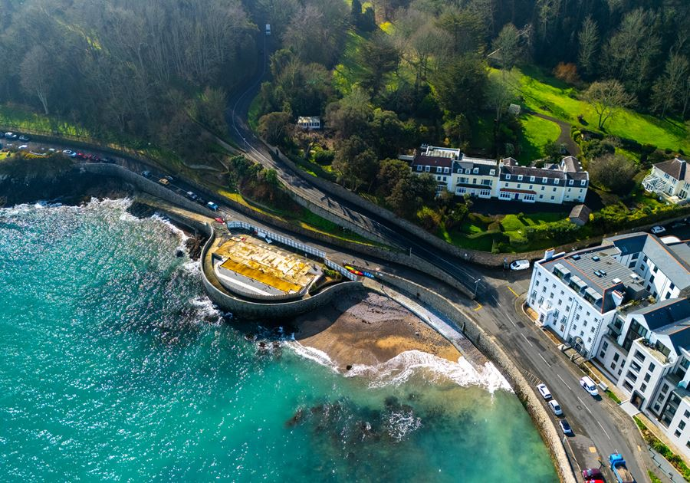

THE ISLAND EXCHANGE
Executive Summary

A civic guesthouse on the sea wall — converting visitor value into island benefit.

Former Octopus Restaurant Site · La Valette · St Peter Port
Written by Oliver Brock, Sonia Mills, Marc Winn, Doug Scott and Cheryl Meerveld
May 2026

There is a wall on the seafront at La Valette that has stood for well over a century.
It has watched the tides — ten metres at extreme spring high, one of the largest tidal ranges in the world. It has watched the harbour fill with sail and then with steam and then with steel. It has watched generations of islanders walk past with bicycles, with shopping, with sandy children, with the day's news, with grief. It has watched the Half Moon café open and close. It has watched the Octopus open and close. It has watched the slab clear, and then sit empty.
We want to build something on the wall. Not beside it — on it, with it, into it. A small dense civic building of granite and oak and brass, where the rooms upstairs pay for the rooms downstairs to belong to the island.
Visitors will sleep here. Islanders will sit here. The wall, the harbour, the bay, the children, the bicycles, the news of the day will all carry on, only with somewhere new to be.

This is the executive summary of how that happens.

The proposition

A civic guesthouse on the sea wall, where premium short-stay visitors fund a public social deck, wellbeing activity and island exchange.
The Island Exchange at La Valette is anchored by a coastal civic building that uses a handful of premium guest residences to cross-subsidise a genuinely public ground floor and middle decks. Around it sits a connected ecosystem: a regulated-finance accelerator (Good Vibrations), a digital platform (The Hive), a countryside retreat (La Cache House), a holistic-health partnership (MAP Health) and a Community Innovation Fund seeded by operating surplus.
Two hundred metres along the coast sit the recently-renovated La Valette Bathing Pools — Guernsey's beloved tidal sea-bathing pools. The Island Exchange is positioned as the seafront's second public anchor, deliberately complementary to (not competitive with) the Pools. Together the two buildings form the public bookends of a properly resourced civic seafront.

Three identities
- A civic guesthouse — premium short-stay rooms whose income funds the public mission
- A public social deck — café, civic room, reading room, therapy and Recovery Rooms, The Dock, roof terrace, all genuinely public
- A place-based coastal landmark — inhabited Victorian sea wall, corner atrium, contemporary architecture rooted in this specific site

The team
- Oliver Brock — co-founder. Guernsey-based architect and community planner; works closely with the Planning Service
- Sonia Mills — co-founder. BACP Accredited Psychotherapist (2,000+ practice hours). Therapeutic and atmospheric framework lead
- Marc Winn — co-founder, MD. Creator of the Ikigai Venn Diagram. Co-founder of the Dandelion Project
- Doug Scott — co-author. Red Brain. Backed Ignite and Entrepreneur First (200+ accelerator companies)
- Cheryl Meerveld — co-author. Clean Language coach, founder of five companies. Programme and community-design lead
- Jeff Faris — clinical backer. 40+ years systemic psychotherapy
- Dr Jo Le Noury — governance & clinical adviser. Retired GP, Chair of Bright Tights
- Avia Willment — La Cache House retreat partner (St Pierre du Bois)

Four concepts that would work

The site can support a range of viable schemes. The four below are all genuinely buildable. Each represents a different idea about what the site is for.

 | A · The Promenade | B · The Exchange | C · The Vessel | D · The Crown
Suites | 0 | 5 | 10 | 12 + 2 long-stay
Storeys | 2–2.5 | 3–3.5 | 4–4.5 | 4.5
GIA approx. | 1,100 m² | 1,800 m² | 2,650 m² | 2,900 m²
Total cost | £8.8 m | £13.2 m | £18.0 m | £19.4 m
Year 3 revenue | £0.85 m | £1.55 m | £2.26 m | £2.55 m
Year 3 op surplus | (modest) | £260 k | £670 k | £810 k
Risk | Low | Low–med | Medium | Med–high

The recommendation
Concept C — The Vessel — is the recommended scheme.
Ten suites (4 signature sea-view + 4 compact premium + 2 civic residency) are required for the corporate retainer + accelerator + civic ecosystem to work as one connected machine.
Concept B is a credible Phase 1 fallback if blended funding proves harder than expected. Concept D is the upside if a major philanthropic anchor emerges.

How it works financially

Three numbers, not one
We are not testing whether the building can generate turnover.
We are testing whether it can generate reliable operating surplus while protecting public benefit.
Turnover is not what pays the bank. Operating surplus is.

Year 3 P&L — Concept C central case

Line | £
Gross income | 2,258,000
Less: operating costs | (945,000)
Operating surplus | 1,313,000
Operating margin | 58%
Less: interest | (645,000)
Less: maintenance reserve (1.5%) | (240,000)
Free cash before principal | 428,000

Funding stack — Concept C, £18m total

Layer | Amount | Cost / terms
Senior debt | £7.2 m (40%) | 6.0–7.0%
Patient capital | £4.5 m (25%) | 3.0–4.0%
Foundation grants | £2.7 m (15%) | Non-dilutive
Founder equity | £1.44 m (8%) | Deferred
Community shares | £1.26 m (7%) | Capped dividend
Civic Room-Night Bank | £0.9 m (5%) | Pre-sold corporate suite packages
TOTAL | £18.0 m | Blended ~3.6%

On the room rate
£425 average daily rate is benchmarked against contemporary architectural-luxury coastal comparables: Lympstone Manor (£350–£500), Burgh Island (£436–£482), Idle Rocks (£263–£400), The Pollurian (£230–£350), The Scarlet (£280–£420). The Old Government House Hotel — Guernsey's only 5-star — is in the £210–£410 band; this scheme is positioned as a different category, not as a higher OGH.

How the public benefit is protected

The mission is hard-coded into the legal structure of the asset-owning body, so that public benefit cannot be quietly eroded if revenue pressure mounts.

1. Community Access Guarantee
Minimum free or below-market hours per four-week period for civic room, meeting room, therapy and Recovery Rooms, reading room, Storm Room and roof terrace. Floors, not targets.

2. Pricing Charter
Café benchmarked against a defined basket of comparable St Peter Port operators. Three-tier rates for meeting rooms (commercial, charity, community). Means-tested subsidy for Recovery Rooms. Islander off-season rates on selected suites.

3. Surplus Waterfall
Operating costs → debt service → maintenance reserve → community access guarantee → community programming → reinvestment → modest capped dividend. No discretionary payment until lines 1–6 are satisfied.

4. Annual Public Report
Income, expenditure, occupancy, community hours delivered, subsidised sessions, trustee-in-residence contributions, local supplier spend. Hand-delivered to every household within 1km for the first three years.

5. Critical Friends Panel
Three to five respected islanders with quarterly access to the operator and annual access to the board. The right to publish their own report.

6. Asset Lock
The building, freehold and reserves cannot be sold or repurposed without a two-thirds board majority, unanimous panel resolution, and a 90-day public consultation.

Full draft constitutional clauses are set out in Appendix D of the Information Memorandum.

Multigenerational by design

The Island Exchange is built, programmed, priced and governed to be useful across the full island lifespan — not as decoration, but as constitutional commitment. Each generational group has spaces, hours, programmes and pricing that meet their actual needs.

Children (under 12, with parents)
Saturday morning storytime in the reading room (free, run with the Guille-Allès Library). Family-rate menu in The Half Moon. Buggy-park with sea-view. School-holiday programming. Wet-weather welcome at no charge.

Teenagers (13–17)
Youth-keyholder zone with WiFi and music practice room. A Youth Council with a £5,000 annual budget and a permanent advisory seat at the Critical Friends Panel. Bursaried Saturday-morning roles in the café for teens from low-income households. Music-friendly evenings programmed by the Youth Council. Mentoring exchanges with visiting trustees.

Working-age adults and parents (25–55)
Childcare-friendly meeting rooms. Breastfeeding-comfortable seating. Family-rate civic room hire. Quiet-work hours in the reading room.

Older adults (65–80)
Tuesday morning coffee group. Friday morning film club. Monthly repair café. Walking-and-talking group along the seafront. Talks programme. 20% off paid programming for residents over 65. "Pay-it-forward" coffee fund.

Frail elderly and people living with dementia (80+)
Full step-free access. Seating every 8m through the building. Dementia-friendly auditing in Phase 1. Monthly memory café. Care-home outings programme with free use of the civic room. Intergenerational music sessions with primary-school choirs. Dignity-first toilets with assistance handles and adult changing facilities.

The constitutional commitment
The youth programme is hard-coded into Clause 3 of the constitutional clauses — the surplus waterfall — at minimum £25,000 per annum. The older-adult programme at £15,000. The dementia-friendly programme at £8,000.
These minimums can only be reduced by unanimous Critical Friends Panel decision and a 90-day public consultation period.
Multigenerational programming is preserved before any non-essential capital expenditure.

The seafront cluster

Two hundred metres along the coast sit the La Valette Bathing Pools — Victorian sea-bathing pools recently renovated by DLM Architects (RIBA South East Sustainability Award 2024), with a year-round café, the wood-fired Hot Haus sauna, modern changing facilities and an established community of regulars. Free. States-owned. Run by the Vive La Vallette charitable trust.
The Island Exchange is positioned as the seafront's second public anchor, deliberately complementary to (not competitive with) the Pools.

Complementary, not competitive
The Pools = swimming, year-round outdoor wellness, casual day-time café, sauna, free, States-owned. The Island Exchange = civic guesthouse, civic room, accelerator, retreat partner, evening dining, longer-format treatments, contemporary architecture.
Specifically: the café at the Island Exchange is positioned as proper food and evening dining (the Tide Table for civic gatherings, longer-format meals, breakfast meetings), not as a competing day-time bacon-bap café. The Recovery Rooms are positioned as treatment infrastructure (physiotherapy, sports massage, longer wellbeing sessions), not as a competing destination sauna. The Dock — secure cycle and motorcycle parking, quick-rinse, lockers, riders' changing — fills a gap that doesn't currently exist at the Pools or anywhere else on this stretch of coast.

Vive La Vallette as collaborator
The first conversation in Phase 0 will be with Vive La Vallette. The aim is a written memorandum of mutual non-competition and mutual benefit: cross-promotion, member reciprocity where appropriate, a coordinated programme of seafront events, shared facilities thinking. The local sea-swimming and outdoor-wellness community is small, well-networked and protective of their place. They should be allies.

The architectural bar
The DLM Bathing Pools building won a RIBA South East Sustainability Award in 2024. It is the standard the Island Exchange has to clear. Generic-modern will not survive the comparison. The architectural brief is set accordingly.

A Guernsey blueprint that can travel

The Island Exchange is not just a building. It is the prototype for a Civic Investment Vehicle — a legal-financial architecture that combines cross-subsidy at architectural scale, a blended six-layer funding stack, six constitutional locks, the Civic Room-Night Bank instrument, and the trustee-in-residence programme.
Most of the elements exist separately elsewhere. The combination, calibrated against a single mature operating model, with public-benefit objects hard-coded into the legal architecture, is genuinely new.

What replicates and what doesn't
- Portable: the legal structure (asset-owning body + trading subsidiary), the constitutional locks, the funding-stack methodology, the Civic Room-Night Bank, the trustee-in-residence programme, the operator structure
- Not portable: the architectural response to a specific coastline, the local unfair advantage that drives the accelerator, the existing community of cyclists, swimmers and walkers, the local ecosystem partners, the team configuration

Candidate locations, honestly assessed
Cork (Custom House Quay) is the strongest natural second instance — harbour-fringe sites, sub-250k population, fintech and pharma clusters, favourable charity and community-shares regulatory environment. Belfast at smaller-than-Titanic-Quarter scale, Newcastle/North Tyneside, Galway, and parts of coastal Cornwall are all plausible at varying levels of fit. Each instance would be locally founded, locally owned, and locally operated; what replicates is the structure, not the chain.

Why this matters for Guernsey
Guernsey has a thousand-year track record of inventing structures that travel — the 1483 neutrality charter, the global trust industry, the Ikigai Venn Diagram. The Civic Investment Vehicle would be the latest, not the first. Pitching the Island Exchange as the prototype for a model that scales materially expands the available capital pool, repositions the project against the right international peer set, and is consistent with what Guernsey has always done. Section 16b of the Information Memorandum sets this out in detail.

What we are asking for

Six specific, actionable things from the people in the room.

1. In-principle support for the development direction
Confirmation that a mixed-use civic-and-hospitality scheme at up to 4.5 storeys, on this site, is the kind of development the room would actively support — subject to detailed design and proper consent.

2. Facilitation of a structured pre-application route with Planning
Coordinated meetings with the Development and Planning Authority, the Heritage Officer, and a Design Review-style scrutiny session.

3. Introductions to four to six local patient-capital prospects
Warm introductions to local high-net-worth individuals, family offices, or trust-company principals whose values align with civic infrastructure.

4. Advice on the community shares regulatory path on Guernsey
A short, specific conversation about how a community-shares-style instrument could be issued under Guernsey law.

5. Letters of comfort or in-principle support for named grant applications
Letters that can be attached to applications to the Guernsey Community Foundation, Guernsey Social Investment Fund, Architectural Heritage Fund, and one or two UK foundations active in wellbeing and youth provision.

6. A small budget to take the project from concept to funded feasibility
£75,000 to £125,000 to cover site-purchase due diligence, pre-application planning engagement, blended-funding term sheets, governance and legal structuring, community consultation, QS pre-tender cost validation, and a fully costed feasibility report.

What we are not asking for
We are not asking for public capital.
We are not asking for a public revenue subsidy.
We are not asking for any transfer of public land.
We are not asking for planning permission to be pre-determined.

Three lines for the room
The wall is not the boundary. The wall is the project.
The roof is the civic gift.
The building converts visitor value into island benefit.

Full Information Memorandum available on request.

